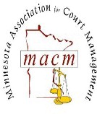
MINNESOTA ASSOCIATION FOR COURT MANAGEMENT
AFFIDAVIT OF NO RECEIPT

I, First Name and Last Name, hereby state that the following Statement of Expense is just, true and correct and that the sums charged were actually disbursed by me in the performance of official duties for the MACM, but that receipts, as required by policy, were either not secured or have been lost by me.

DATE | ITEM | AMOUNT

_______________________________________________
Member Signature and Printed Name with Date

